Template: Output Efficiency Analysis
Country: China (chosen country)
Year: 2018
Sector: Manufacturing Transport Equipment (chosen sector)
Condition: Application of 5G technology in the chosen sector. This has caused an expansion of the industry production capacity by 15% since 2019.
What is the purpose of output efficiency analysis?
- Analyse production capacity when specific sector(s) expand (in this case is expand) or contract due to the adoption of technology.
Results
Table 1. Values of multipliers for the Overall Economy in 2018
Indicators | Direct Effects | Indirect Effects | Induced Effects | Total Effects
Output ($) | 0.8992 | 2.9913 | 19.3788 | 23.2693
Employment (per person)* | 13 | 39 | 301 | 353
Value-Added ($) | 0.2015 | 0.8237 | 6.9874 | 8.0127
Import ($) | 0.0493 | 0.1562 | 0.7158 | 0.9213
Tax ($) | 0.0000 | 0.0000 | 0.0000 | 0.0000
Export ($) | 0.0692 | 0.2383 | 0.9400 | 1.2475
* Must be interpreted with $1 million increase in final demand
Interpretation for Table 1
  - With $1 million increase in final demand of the chosen sector, there was a total increase of employment by 353 in within the chosen country.
  - With $1 increase in final demand of the chosen sector, there was a total increase of $8 of value-added in the economy.

Table 2. Values of multipliers for the chosen sector in 2018
Indicators | Direct Effects | Indirect Effects | Induced Effects | Total Effects
Output ($) | 0.3275 | 1.1921 | 0.4196 | 1.9392
Employment (per person)* | 13 | 7 | 5 | 25
Value-Added ($) | 0.2015 | 0.1047 | 0.0846 | 0.3908
Import ($) | 0.0493 | 0.0256 | 0.0207 | 0.0956
Tax ($) | 0.0000 | 0.0000 | 0.0000 | 0.0000
Export ($) | 0.0692 | 0.0360 | 0.0290 | 0.1342
* Must be interpreted with $1 million increase in final demand
Interpretation for Table 2
  - With $1 million increase in final demand of the chosen sector, there was an additional 25 jobs created in the chosen sector.
  - With $1 increase in final demand of the chosen sector, there was a total increase of $0.39 of value-added within the chosen sector.
Concepts
- Direct effect is the immediate impact of a change in economic activity in the chosen sector where change occurs.
- Indirect effect is the secondary effects on industries that supply goods and services to chosen sector.
- Induced effect is the additional economic activity generated by increased household income.
- Total effect captures the full economic consequences from the initial change.
- Calculation of each indicator:
$$Output value =\frac{Value of Output Multiplier}{Change in final demand of the chosen sector }$$
$$Employment No. =\frac{Value of Employment Multiplier}{Change in final demand of the chosen sector }$$
$$Value-Added =\frac{Value of Value-Added Multiplier}{Change in final demand ofthe chosen ector }$$
$$Import =\frac{Value of Import Multiplier}{Change in final demand of the chosen sector }$$
$$Tax =\frac{Value of Tax Multiplier}{Change in final demand of the chosen sector }$$
$$Export =\frac{Value of Export Multiplier}{Change in final demand ofthe chosen sector }$$

Figure 1. Baseline and Actual Values of Multiplier Indicators of the chosen sector from 2011 to 2023
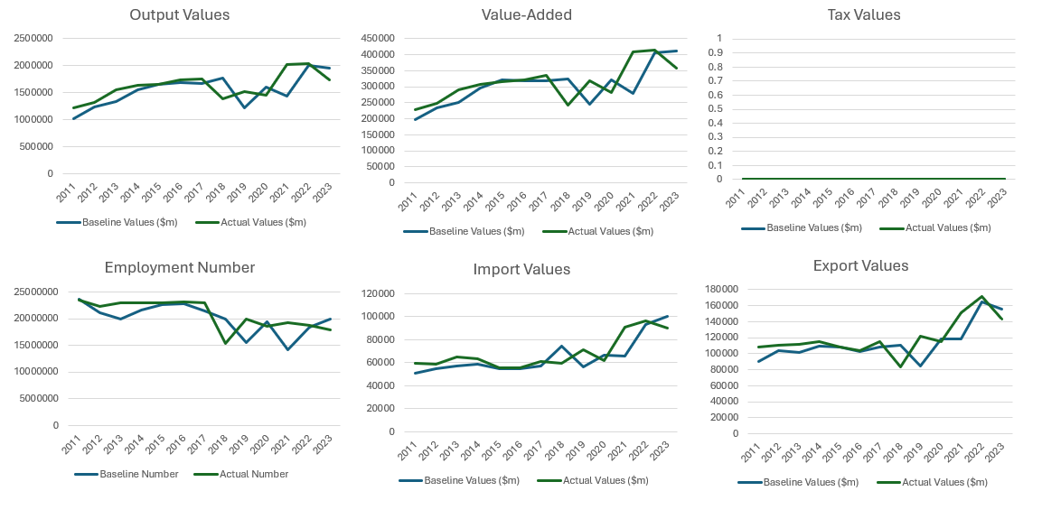
- Baseline values represent the benchmark for comparison. It excludes the effects of intervention of policies from the previous period. It serves as a benchmark to evaluate the impact of new strategies, policies, or scenarios.
- Actual values represent the real outcomes once events have occurred.
Figure 2. Baseline values of the chosen country’s environmental indicators
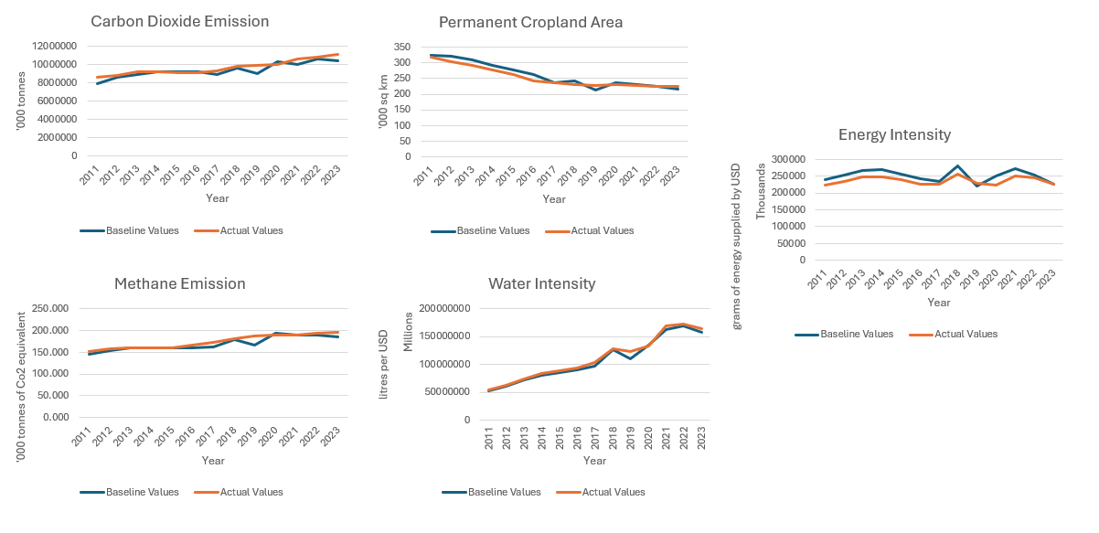
- The overall emissions of gases and usage of resources of the chosen country across the period of 2011 and 2023.
What additional features available in the web application to perform different types of analysis?
- Performing expansion of production capacity of a or a few sector(s) for the period between 2011 and 2023.
- Stimulation of Investment, Government spending, or Exports
- Stimulation of scenarios to assess its impact on environment, including carbon dioxide emissions, methane emissions, permanent cropland area, water usage intensity, and energy intensity
Notes:
- Do you wish to know who are the key sectors that are related to the chosen sector in the chosen country (Refer to template Industry Classification)
- What are the roles of the chosen sector and its supply chain play in the chosen country’s economy? (Refer to template Supply Chain Network Analysis)
- Want to discover other scenarios for better business planning? The other scenarios include:
Scenario Analysis | Explanation
Production Efficiency Analysis | Producing goods and services using the least resources/cost. Aiming for cost minimization, reducing cost per unit of production or increasing output per dollar spent.  E.g., produce output with the least resources and energy possible without wasting any of the resources. A company uses X amount of resource and Y energy (e.g., electricity) to produce Z outputs. The company has successfully found a way to produce Z outputs with less amount of resources and energy.
Output Efficiency Analysis | Maximizing output from given inputs. It focuses on producing more outputs from the given resources and energy (e.g., increase outputs per hour).  Understanding how well the product process converts inputs into outputs. E.g. A company uses X amount of resource and Y energy (e.g., electricity) to produce Z outputs. Now, the company able to produce more Z outputs with the same X amount of resource and Y energy (e.g., electricity).
Economic Efficiency Analysis | Optimize resource allocation to maximize society benefits. The company is maximizing the profit per output by reducing cost and meeting the consumers’ preferences.  E.g., A company is selling a board model A with $20, the cost of production per unit is $ 5, profit will be $15. After improving the production process, the unit cost of production has been reduced to $4. The market demand for board model B is preferable. Thus, the company decided to increase the production for board model B and sell at $25 in the market leading to an increase in profit of $21 per unit.
Crisis Response Analysis | Analyse the impact of production disruption which halted production of a or a few sector(s).
Total Factor Productivity Analysis | Analyse the impact of changes in input costs onto output prices.

