Template: Industry Classification
Country: Indonesia (chosen country)
Year: 2022
What is the purpose of the industry classification?
- What role does the sector play in the economy?
Explanation:
Table 1. Classification of industries based on normalised backward and forward linkages
 |  | Normalised Forward Linkage
 |  | Low (<1) | High (>1)
Normalised Backward Linkage | High (>1) | (Quadrant 2)  Backbone Sectors  (Essential in generating demands for other sectors)  Dependent on interindustry supply | (Quadrant 1)  Fast Gowing Sectors  (Integral to economic growth and lay a central role in driving economic growth as they have strong connections to other sectors)  Generally dependent
Normalised Backward Linkage | Low (<1) | (Quadrant 3)  Emerging Sectors  (Promising new frontiers that will play a critical role in shaping the future economy)  Generally independent | (Quadrant 4)  Net Distributor Sectors  (Suppliers of essential goods and services to other sectors, widespread influence to the downstream of sectors)  Dependent on interindustry demand

Results:
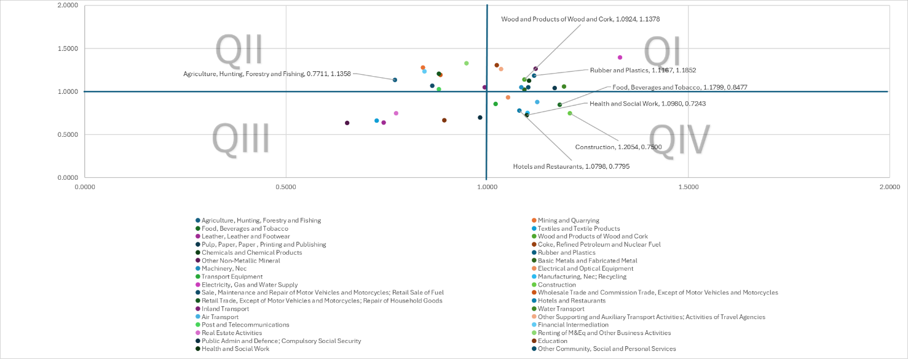

Notes:
- How to integrate economic transformation plan with business strategic plan? It can be tested based on different scenarios.
- Ready to take your business strategy to the next level? Discover how strategic scenario planning can elevate your decision-making in the scenario analysis template:
Scenario Analysis | Explanation
Production Efficiency Analysis | Producing goods and services using the least resources/cost. Aiming for cost minimization, reducing cost per unit of production or increasing output per dollar spent.  E.g., produce output with the least resources and energy possible without wasting any of the resources. A company uses X amount of resource and Y energy (e.g., electricity) to produce Z outputs. The company has successfully found a way to produce Z outputs with less amount of resources and energy.
Output Efficiency Analysis | Maximizing output from given inputs. It focuses on producing more outputs from the given resources and energy (e.g., increase outputs per hour).  Understanding how well the product process converts inputs into outputs. E.g. A company uses X amount of resource and Y energy (e.g., electricity) to produce Z outputs. Now, the company able to produce more Z outputs with the same X amount of resource and Y energy (e.g., electricity).
Economic Efficiency Analysis | Optimize resource allocation to maximize society benefits. The company is maximizing the profit per output by reducing cost and meeting the consumers’ preferences.  E.g., A company is selling a board model A with $20, the cost of production per unit is $ 5, profit will be $15. After improving the production process, the unit cost of production has been reduced to $4. The market demand for board model B is preferable. Thus, the company decided to increase the production for board model B and sell at $25 in the market leading to an increase in profit of $21 per unit.
Crisis Response Analysis | Analyse the impact of production disruption which halted production of a or a few sector(s).
Total Factor Productivity Analysis | Analyse the impact of changes in input costs onto output prices.

